
SUBMITTED BY:
ZULQARNAIN HASSAN

SUBMITTED TO:
SIR M.BIALA SHAHNAWAZ
Subject: ……………………………………….. OOPs
Roll No: ………………………………………… 21379
Section: …………………………………………. BSSE-II-A-afternoon
Assignment:…………………………………….Frist
Date:……………………………………………….07-oct-2022

Assignment # 01
CLO 1: Understand principles of object oriented paradigm.

=============================================================
Note:
Assignment will only be submitted to me in your corresponding class else it will not be accepted.
- Copy Paste not allowed (otherwise marks deduction)
- No Handwritten Assignment (Printed Assignment)
=============================================================
Question #1: What is a Jagged Array in Java?

Array:
Arrays are the containers that store multiple variables of the same data type. These are of fixed size which is determined at the time of creation. Each element in an array is positioned by a number starting from 0.

Jagged Array:
Multi-dimensional arrays in Java with variable number of columns is known as a jagged array.

For example:

import java.util.Arrays;
public class twoDarray
{
public static void main(String args[])
{
int[][] myarray = {{1,2,3}, {4,5,6}, {7,8,9} };

System.out.println("array elements are : ");

for(int i=0;i<3;i++)
{
for(int j=0;j<3;j++)
{
System.out.print(" "+myarray[i][j]);
}
System.out.println();
}
}
}
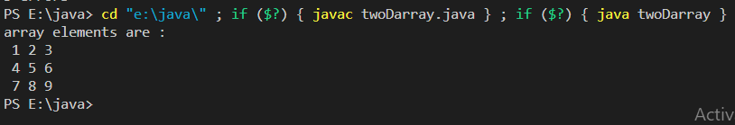

Question #2: Write a code using jagged array to print the following output:
0
1 2
3 4 5
6 7 8 9
10 11 12 13

Import java.util.Array;
Public class juggedarray
{
Public static void main(String args[])
{
Int [][] myarray=new int[5][5];
myarray[0][0]=0;
myarray[1][0]=1;
myarray[1][1]=2;
myarray[2][0]=3;
myarray[2][1]=4;
myarray[2][2]=5;

myarray[3][0]=6;
myarray[3][1]=7;
myarray[3][2]=8;
myarray[3][3]=9;
myarray[4][0]=10;
myarray[4][1]=11;
myarray[4][2]=12;
myarray[4][3]=13;
for(int i=0;i<myarray.lenght;i++)
{
For(int j=0;j<i+1;j++)
{
if(j!=4)
{
System.out.print(“ “ +myarray[i][j]);
}
}
System.out.println(“ “);

}
}
}

